Pairwork Activities for ESL students - Famous Places

Famous Places
5 activities for ESL learners
Introduction:
The following 5 activities are designed for ESL learners in a year 5/6 classroom. The learners would be aiming towards upper primary level B3 according to the English as a Second Language (ESL) Companion to the Victorian Essential Learning Standards [VELS] (2005). The learning focus for level B3 learners according to the VELS companion includes:
- learning to use language which is increasingly appropriate to the context
- communication in a full range of classroom context, clarifying and sharing ideas
- observation, use and reflection on effective and appropriate ways of using English for different purposed and audiences
- initiation and maintenance of spoken interaction in a range of activities
Regarding speaking and listening at this level the VELS companion states that students:
- generally respond to and use the structures and features of English appropriately
- understand the essential meaning of unfamiliar topics expressed in spoken English
- use comprehensible pronunciation, stress and intonation
- access English from a range of oral and written sources
- self correct and reformulate language to convey meaning more clearly

And regarding reading, the VELS companion states that students at B3 level should:
- identify main ideas and specific information in classroom texts
- compare some details in texts
- demonstrate understanding of the main storyline
- demonstrate some awareness of how information is organised in English texts
- recognise the cohesive devices connecting ideas and the organisation of information in a text

Information taken from:
Victorian Curriculum and Assessment Authority. (2005) English as a second language (ESL)
companion to the Victorian Essential Learning Standards. Retrieved from
http://vels.vcaa.vic.edu.au/downloads/esl_companion.pdf

Activities:

The following 5 activities have been aimed towards level B3 learners. The activities have been designed to have children working in pairs, communicating with each other in order to achieve the goals of the activities. The goals have been designed alongside the learning focus and standards listed on the previous page. It has been assumed that the children have already been studying Famous Places as a topic in the classroom and will be familiar with the places used in the activities.

Activity 1: Where in the world?

One student has a map of Europe with 6 famous places on it. The other student has a map and has to cut out the famous places from his/her activity sheet and glue them to the map on the correct country according to their partners’ instructions.
This complies with the learning focus where children will be using language appropriate to the context and communicating by using effective and appropriate English. It also involves children using prepositions to describe where to position the famous places on the map.

Activity 2: Mixed up paragraphs

Each student has a topic, either the Sydney Opera House or the Louvre. 2 paragraphs of information about the topics have been cut up into sentences (5 sentences per child) and each child has to reconstruct their own paragraph. Children then have to read aloud their paragraph to their partner and confer whether the sentences could be moved around to make more sense.
From this students will demonstrate understanding of sequencing and comparing details in texts. They will also demonstrate awareness of how information is organised in English texts as described in the VELS companion for this level. Children will use grammar including definite and indefinite articles.

Activity 3: What’s on the card?

One student chooses a card from a pile of cards picturing famous places. The other student has to ask questions about the card until he works out what the famous place is. Children take turns in guessing.
Children will adhere to the learning focus by communicating in language appropriate to the subject. Grammar included present form of verbs e.g. “does it have........?”

Activity 4: Wish List

Student A chooses a famous place from the list and says “I would like to go to (The Pyramids).....”
Student B finishes the sentence using appropriate language e.g. “because I have read a lot about them”. Now student B chooses a place and student A needs to finish the sentence.
This activity involves communication and sharing ideas, using appropriate English, responding to structures of English appropriately and reasoning. It involves describing why the student would like to visit that particular place using the subordinating conjunction ‘because’ to join an independent and a dependent clause. Children will also use grammar including definite and indefinite articles and appropriate adjectives.

Activity 5: Information Gap

Each student has a table with facts about famous structures. Different information is missing from each student’s sheet. Students must ask each other questions to fill in the gaps on their sheets until they are both complete.
This activity involves students with a shared goal of filling in their information. Students need to ask appropriate questions to gain the information to complete their sheet, for example, “do you know what the length of the Golden Gate Bridge is?”

ACTIVITY 1 - Where in the world?
Student A instructions:
Student B has the same map as you but the famous places are correctly positioned on their map.
Cut out the famous places below and paste them onto the map according to your partner’s instructions.

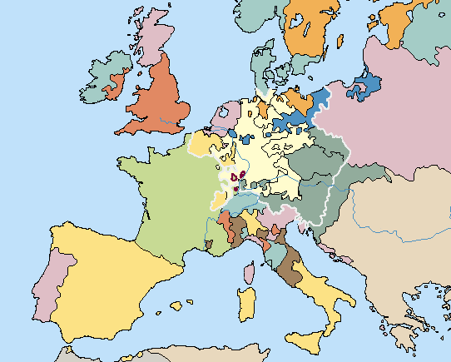
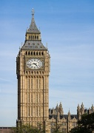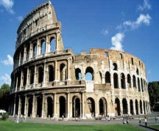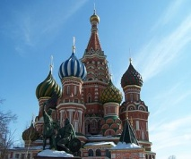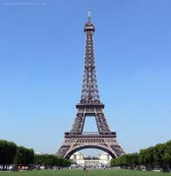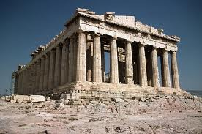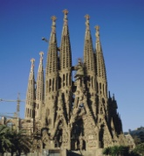

ACTIVITY 1 - Where in the world? Continued

Student B instructions:

Student A has the same map but without the famous places positioned correctly on it. You must describe to them where to place the famous items on their map.

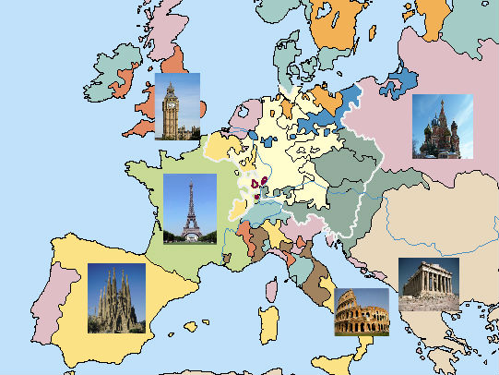

Activity 1: Where in the world?

Language functions | Language Structures | Vocabulary
Giving/following instructions  Describing  Questioning  Expressing position  Explaining | Where should I put........?  Does it go near?  Is it near.........?  It goes......  Put it near/on/next to......  It is near/above/below/to the  right of/ left of............ | Big Ben/clock  Colosseum/ruins  Acropolis  Sagrada Familia/church/cathedral  Red Square  Eiffel Tower  Next to/  under/beside/near/right/left  Island  Country  Map  Pink/blue/orange/green/yellow etc  Joined  England, Italy, Greece, Russia, Spain, France  London, Rome, Athens, Moscow,  Barcelona, Paris

Activity 2 – Mixed up paragraphs
Student A

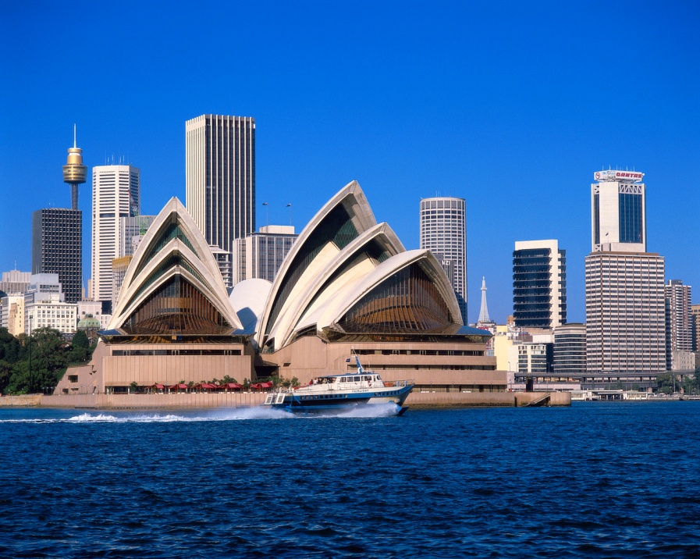

Below there are two mixed up paragraphs, one is about the Sydney Opera house and the other is about the Louvre in Paris. You and your partner are to reconstruct a paragraph each. Your topic is the Sydney Opera House. When you have finished read the paragraphs aloud to each other to make sure that you have all the right information in an order that makes sense.

(tip: it might be easier to cut the text into sentences first)

The museum was opened in 1793. It is one of the busiest performing arts centres in the world. It is situated in Paris, France. It is situated in Sydney, Australia. It was designed by a Danish architect and opened in 1973. It is an iconic building of the 20th century. It is one of the world’s largest museums. It is a performing arts centre. It was originally a palace which was built in the 12th century. It is the most visited art museum in the world.

Activity 2 – Mixed up paragraphs

Student B

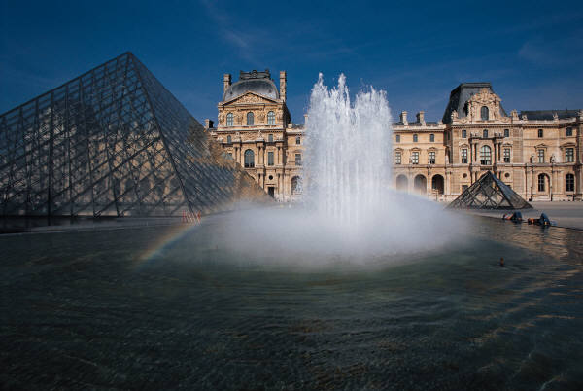

Below there are two mixed up paragraphs, one is about the Sydney Opera house and the other is about the Louvre in Paris. You and your partner are to reconstruct a paragraph each. Your topic is the Louvre. When you have finished read the paragraphs aloud to each other to make sure that you have all the right information in an order that makes sense.

(tip: it might be easier to cut the text into sentences first)

The museum was opened in 1793. It is one of the busiest performing arts centres in the world. It is situated in Paris, France. It is situated in Sydney, Australia. It was designed by a Danish architect and opened in 1973. It is an iconic building of the 20th century. It is one of the world’s largest museums. It is a performing arts centre. It was originally a palace which was built in the 12th century. It is the most visited art museum in the world.

Correct construction of paragraphs for Activity 2: Mixed up Paragraphs
The Sydney Opera House
It is a performing arts centre. It is situated in Sydney, New South Wales, Australia. It was designed by a Danish architect and opened in 1973. It is an iconic building of the 20th century. It is one of the busiest performing arts centres in the world.
The Louvre
It is one of the world’s largest museums. It is situated in Paris, France. The museum was opened in 1793. It was originally a palace which was built in the 12th century. It is the most visited art museum in the world.

Activity 2 : Mixed up paragraphs

Language functions | Language structures | Vocabulary
Sequencing  Describing  Evaluating  Hypothesising  Classifying | This one comes first/next/after  This one is about the Louvre  because......  This one belongs to my paragraph because.......  Would this sentence belong to your paragraph because...? | First, next, after, before  Sydney, Australia  Paris, France  Museum, opera house  Century  Older, recent  Building  Palace  Largest

Activity 3 - What am I?
(For the purpose of this activity please assume that the Famous Places cards have been cut out and placed in a pile)
Student A - instructions

Choose a card from the pile. Do not tell your partner what is on the card. Your partner has to question you about the card and try to guess what is on the picture. When your partner guesses your card it is their turn to choose a card and your turn to guess what their card is.

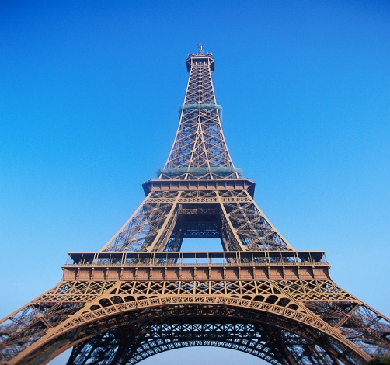 | 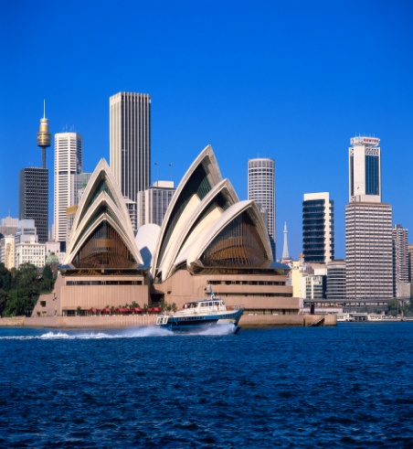 | 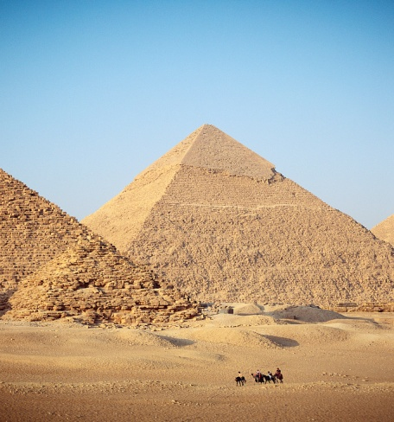
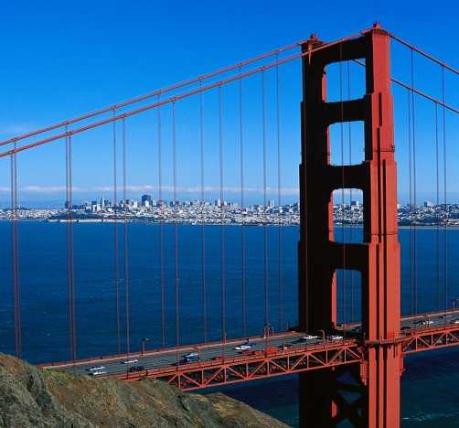 | 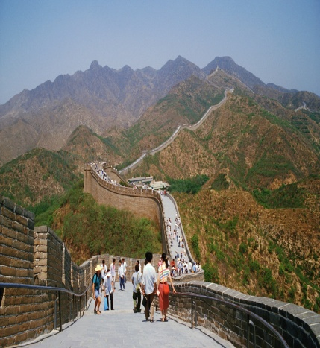 | 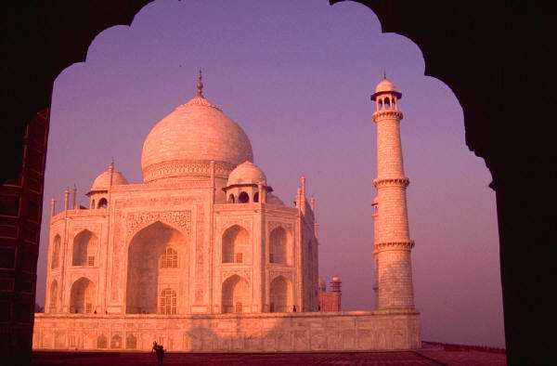
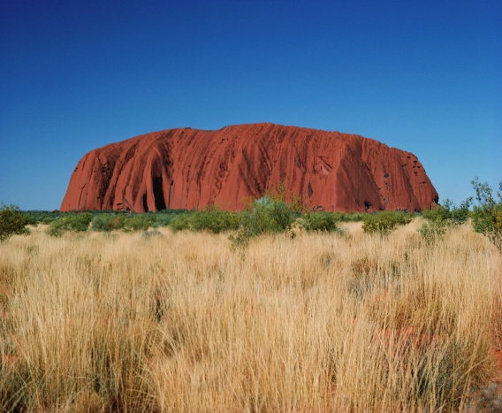 | 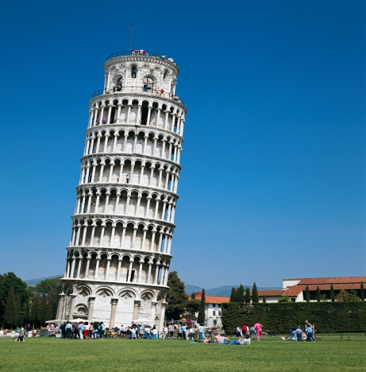 | 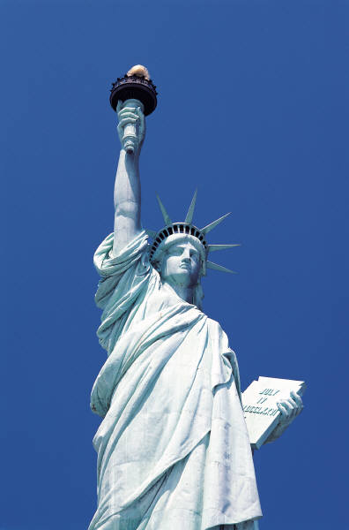

Activity 3: What’s on the card? continued
Student B - instructions

Your partner has chosen a card with a picture of a famous place on it. You need to ask questions until you work out what picture is on the card. When you have guessed correctly, choose a card from the pile and your partner will try to guess what card you have. Take it in turns to guess until all cards have gone.

Activity 3 : What’s on the card?

Language Functions | Language Structures | Vocabulary
Questioning | Is it a?  Can you (climb it?)  What country is it in? | Building  Bridge  Statue  Wall  Rock  Man made  Statue of Liberty, Leaning Tower of Pisa, Ayers Rock, Sydney Opera House, Great Wall of China, Eiffel Tower, Taj Mahal, Pyramids, Golden Gate Bridge  USA, Italy, China, Australia, France, India, Egypt

Activity 4: Wish list
Student A instructions

Choose a famous place from the list below –

Grand Canyon | Great Barrier Reef | Great Wall of China | Pyramids
Niagara Falls | Hollywood | Leaning Tower of Pisa | Washington DC
Statue of Liberty | Berlin Wall | New York City | Buckingham Palace

Say “I would like to go to ..........................................................”

Student B must complete the sentence with “because.......................................”

E.g. Student A : “I would like to go to the colosseum”
Student B : “because I have always wanted to go to Italy”

Now swap places. Continue until you have made a sentence for each place on the list.

Activity 4: Wish list continued
Student B instructions

Student A has chosen a famous place from the list below –

Grand Canyon | Great Barrier Reef | Great Wall of China | Pyramids
Niagara Falls | Hollywood | Leaning Tower of Pisa | Washington DC
Statue of Liberty | Berlin Wall | New York City | Buckingham Palace

Student A will start a sentence with “I would like to go to ..........................................................”

You must complete the sentence starting with “because.......................................”

E.g. Student A : “I would like to go to the colosseum”
Student B : “because I have always wanted to go to Italy”

Now swap places. Continue until you have made a sentence for each place on the list.

Activity 4 : Wish List

Language Functions | Language Structures | Vocabulary
Describing  Explaining  Reporting | I would like to go to.......  Because it is.....  Because I have.......  Because I would like....... | Grand Canyon  Great Barrier Reef  Great Wall of China  The Pyramids  Niagara Falls  Hollywood  Washington DC  New York City  Berlin Wall  Buckingham Palace  Leaning Tower of Pisa  Big, famous, beautiful, far  away, historical, amazing,

ACTIVITY 5 – Information Gap: Each student has a different and incomplete version of the table below showing different facts about famous structures. Students have to ask each other questions in order to complete their tables.
(TEACHER COPY)
 | Completed in (year) | Country | Length
Golden Gate Bridge  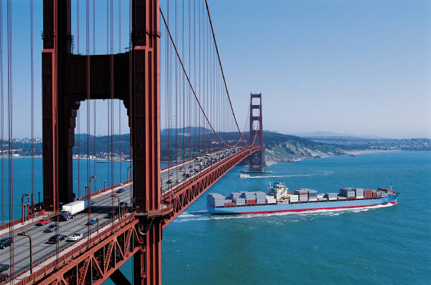 | 1937 | USA | 2737m
Sydney Harbour Bridge  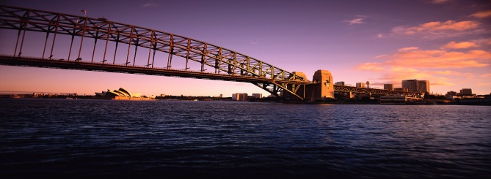 | 1932 | Australia | 1149m
Great Wall of China  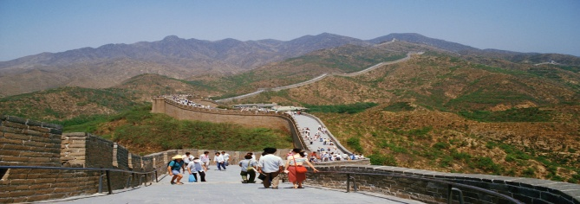 | 1644 | China | 8851km
Berlin Wall  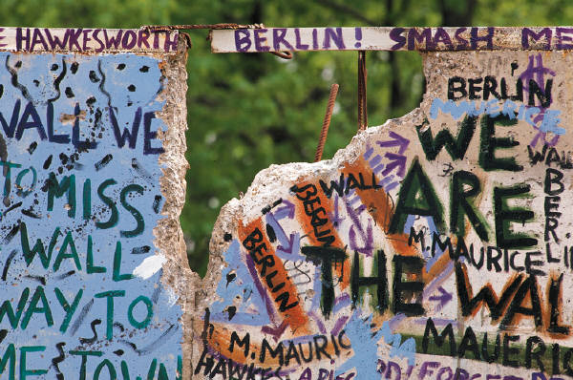 | 1961 | Germany | 155km
Activity 5- Information Gap
Student A: Your partner has the facts that you are missing on your sheet. Ask your partner questions to gain the facts until you have filled in the sheet.
 | Completed in (year) | Country | Length
Golden Gate Bridge | 1937
Sydney Harbour Bridge |  | Australia
Great Wall of China |  | China | 8851km
Berlin Wall | 1961 |  | 155km

Student B: Your partner has the facts that you are missing on your sheet. Ask your partner questions to gain the facts until you have filled in the sheet.
 | Completed in (year) | Country | Length
Golden Gate Bridge |  | USA | 2737m
Sydney Harbour Bridge | 1932 |  | 1149m
Great Wall of China | 1644
Berlin Wall |  | Germany

Activity 5: Information Gap – Famous Structures

Language Functions | Language Structures | Vocabulary
Questioning  Reporting | Do you have..........?  Can you tell me.....?  What year.......?  When was........?  How long.........?  What country......?  I have...........  I need........... | Year  Length  Metres  Kilometres  Country  Germany  Australia  USA  China

